**Project 4 - Cube Mapping Reflective and Refractive Bump-mapped Surfaces**

Explanation:

I had re-written all of my code for this assignment, as I was having some issues with importing the reflection/refraction.

I had started with mapping in the new cube asset, the Nvidia lobby. After pruning some lighting assets, I was good to go.

After correcting my surface normals and collecting my z value, I pass them to my frag file, where i use the eye coordinates as well as the reflect/refract vector to get a correct looking effect. After initially implementing the refraction, I noted that my bump mapping no longer worked, I fixed this segment up by placing it in a separate method which seemed to resolve my issues. This went on for a few more features until I managed to resolve each issue.

I did end up doing a lot of trial and error in resolving most of my issues, I believe if I started the project earlier, I would have been able to make the refraction a bit nicer.

Video:

<https://media.oregonstate.edu/media/t/0_nuognfif>

Mixing:

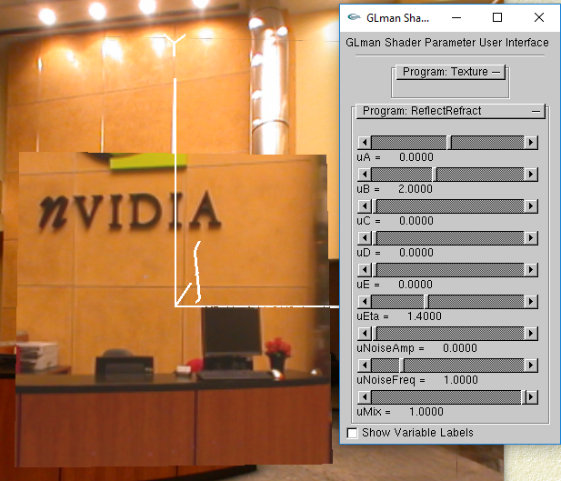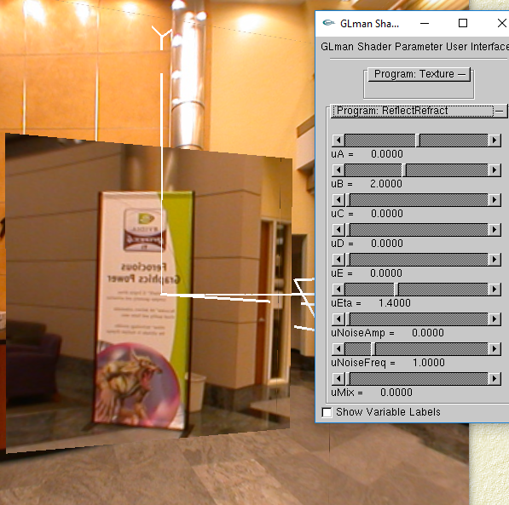

uA

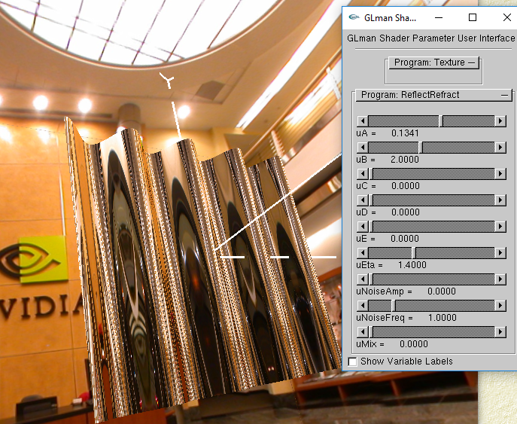

uB

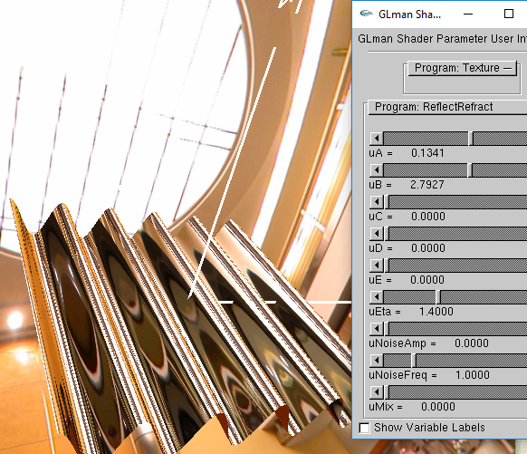

uD

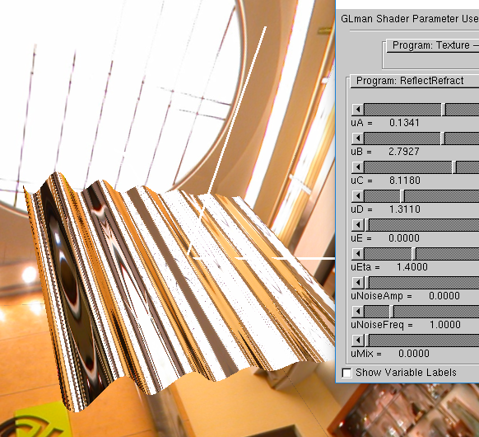

uE

